Middle Tennessee Consumer Outlook Index
September 11, 2014

The Office of Consumer Research
Jones College of Business
at Middle Tennessee State University
Director -- Timothy R. Graeff, Ph.D.
Tim.Graeff@mtsu.edu, 615-898-5124

Consumers’ Outlook Remains Positive

Overall, local consumers continue to feel good about the economy. The overall Middle Tennessee Consumer Outlook Index rose to 226 from 203 in May of this year.

Consumers continue to feel increasingly more positive about the current state of the economy. The Current Situation Index continued its steady rise, increasing to 48 from 38 in May. The percent of consumers who said that the state of the overall American economy was “good” gained to 21 from 17 in May. Similarly, the percent who said that the Middle Tennessee economy is “good” rose to 51 from 48.

The Middle Tennessee Consumer Outlook Index and Components
 | Jan  ‘12 | Apr ‘12 | Sept ‘12 | Nov ‘12 | Feb ‘13 | Apr ‘13 | Sept  ‘13 | Dec ‘13 | Feb ‘14 | May ‘14 | Sep ‘14
Overall Outlook Index | 151 | 184 | 178 | 106 | 144 | 193 | 199 | 122 | 179 | 203 | 226
Current Situation Index | -55 | -24 | -26 | -22 | -16 | 1 | 18 | 3 | 23 | 38 | 48
Future Expectations Index | 125 | 115 | 112 | 55 | 78 | 97 | 86 | 49 | 85 | 86 | 80
Purchasing Index | 81 | 93 | 92 | 73 | 82 | 95 | 95 | 70 | 71 | 79 | 98

Additionally, the Purchasing Index gained to 98 from 79 in May. This is good news for local businesses as many retailers begin setting their sights on the ever important Christmas and Holiday shopping season. This positive view toward spending could signal healthy sales at the cash register later in the year. Those in the auto industry will be pleased to hear that the percent of consumers who said that now is a “good time” to buy a car rose to 48 from 37 in May.

The perception of the job market remains an important component to consumers’ view of the economy. While the percent who said that jobs in Middle Tennessee are “easy to find” dropped slightly to 14 from 16, the percent who said that in Middle Tennessee six months from now there will be “more job openings” rose to 38 from 33.

On a cautionary note, local consumers have become a bit more concerned about the future of the American economy. The Future Expectations Index dropped to 80 from 86 in May. This was due almost entirely to concerns about the future of the overall American economy. The percent of consumers who said that six months from now business conditions in the country as a whole will be “better” dropped to 22 from 31. Recent uncertainty with world events could explain why consumers are taking a bit more cautious view of our economic future.

Overall, however, these results are very positive. The fact that the overall Outlook Index has remained above 200 since May of this year indicates that consumers believe that the economy has improved and has begun to gain a solid footing. However, concerns about the future of the overall American economy are evident. Any drastic changes in world events could cause consumers to lose confidence and decrease spending in reaction to potential threats to continued economic growth.

The current poll of 343 randomly selected adult residents of Davidson County, Rutherford County and Williamson County was conducted between the evenings of Monday, September 8 and Wednesday, September 10.

Annual Consumer Spending

As consumers become more upbeat about the economy this can have positive effects on their spending decisions. When asked whether or not they expect their level of consumer spending for 2014 to be more or less than it was for 2013, the percent of consumers who expect to increase their spending remained steady while the percent who expect to decrease their spending dropped to 20 from 23.

Consumer Savings

Many consumer spending decisions are based on the availability of money that is in the form of savings. When asked about the amount of their income that they are currently saving compared to last year, 26 percent reported saving more (down from 30 percent in May), and 25 percent reported saving less than they were saving last year (up from 23 percent in May). This suggests a slight decrease in the level of consumers’ savings. When asked about future savings, 34 percent expect to increase their level of saving in the future (unchanged from May) and 18 percent expect to decrease their level of saving in the future (down from 20 percent in May).

Taxes

Consumers’ ability to spend can be significantly impacted by the amount of money that they must pay in taxes. Fears of higher taxes in the future continue to wane. The percentage of consumers who expect their taxes to increase in the future fell to 50 from 62 in May.

Consumer Investments: The Stock Market

Uncertainty surrounding recent world events has apparently caused consumers to lose some optimism regarding the stock market. Compared to May, fewer consumers expect the stock market to rise in the next 12 months, whereas more consumers expect the stock market to decline.

Perceptions of the Economy: Comparison to The Nation

While local consumers have some similar views of the economy as compared to consumers across the rest of the country, local consumers are noticeable more optimistic about the future of the job market and the future of their personal finances.

Comparing Middle Tennessee Consumers to  Consumers Across the Country as a Whole | Nation  (%) | Mid.  Tenn.  (%)
Business conditions in the U.S. are good. | 24 | 21
Six months from now, business conditions in the U.S. will be better. | 20 | 22
Jobs are easy to find (plentiful). | 18 | 14
Six months from now, there will be more job openings. | 17 | 38
In 12 months my personal financial situation (income) will be better. | 16 | 32

What Was on Consumers’ Minds?

Consumers were given an opportunity to offer a reason for why they rated the economy as they did. Below is a word cloud that depicts the 25 most frequently mentioned words that appeared in these open-ended responses. The larger the word, the more frequently it was mentioned. This can provide clues about the thoughts that were on consumers’ minds as they responded to the survey. Apparently, consumers perceive that the economy has improved.

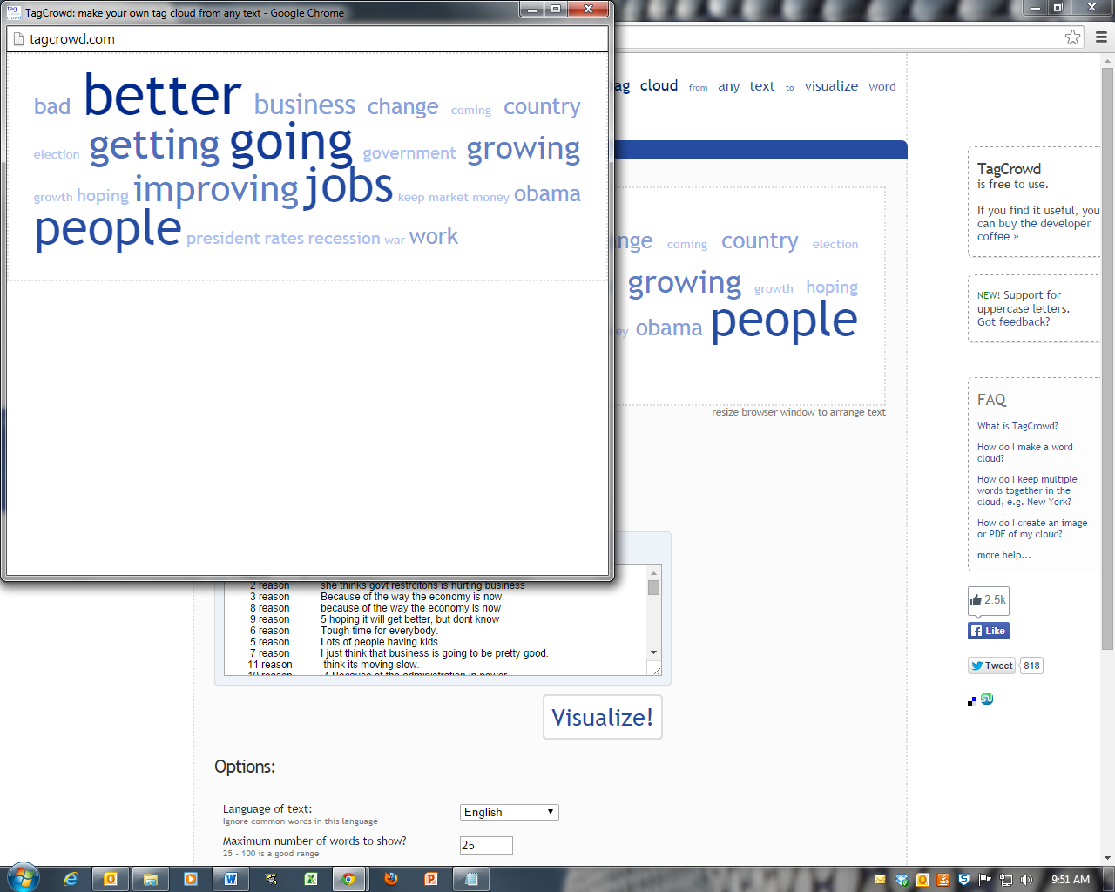
Changes in Consumers’ Perceptions of the Economy

The table below shows how consumers’ responses to selected survey questions have changed since May, 2014.

 | September  2014  (%) | Change from  May 2014
Business conditions in the U.S. are Good. | 21 | 4%
Six months from now, business conditions in the U.S. will be Better. | 22 | 9%
Business conditions in Middle Tennessee are Good. | 51 | 3%
Six months from now, business conditions in Middle Tennessee will be Better. | 33 | No Change
Jobs in Middle Tennessee are Easy To Find. | 14 | 2%
Six months from now there will be More Job Openings in Middle Tennessee | 38 | 5 %
I am Better Off Financially than I was one year ago. | 25 | 4%
12 months from now I will be Better Off Financially than I am today. | 32 | 1%
Now is a Good Time To Make Large Purchases. | 32 | No Change
Now is a Good Time To Buy A Home. | 55 | 1%
Now is a Good Time To Buy A Car. | 48 | 11%

Consumer Outlook |  | Sept | Nov | Jan | Apr | Sept | Dec | Feb | May | Sept
 |  | ‘12 | ‘12 | ‘13 | ‘13 | ‘13 | ‘13 | ‘14 | ‘14 | ‘14
 |  | (%) | (%) | (%) | (%) | (%) | (%) | (%) | (%) | (%)
Are business conditions | Good | 11 | 14 | 14 | 13 | 14 | 12 | 15 | 17 | 21
in the U.S. | In Between | 59 | 60 | 62 | 62 | 66 | 61 | 62 | 66 | 62
 | Bad | 29 | 25 | 23 | 24 | 20 | 26 | 22 | 17 | 15
Six months from now, | Better | 35 | 35 | 34 | 33 | 30 | 25 | 29 | 31 | 22
will business conditions | About same | 38 | 34 | 41 | 46 | 48 | 47 | 47 | 49 | 57
in the U.S. be: | Worse | 13 | 28 | 22 | 19 | 20 | 25 | 22 | 18 | 17
Are business conditions | Good | 40 | 35 | 42 | 44 | 49 | 42 | 50 | 48 | 51
in Middle TN: | In Between | 46 | 53 | 48 | 45 | 46 | 47 | 38 | 43 | 40
 | Bad | 11 | 10 | 8 | 9 | 5 | 9 | 11 | 7 | 6
Six months from now, | Better | 37 | 36 | 36 | 39 | 37 | 27 | 35 | 33 | 33
will business conditions | About same | 46 | 45 | 52 | 49 | 51 | 59 | 55 | 57 | 53
in Middle TN be: | Worse | 7 | 18 | 10 | 10 | 10 | 11 | 7 | 8 | 10
Are jobs in Middle TN: | Easy to find | 4 | 7 | 5 | 8 | 8 | 12 | 13 | 16 | 14
 | Found  w/effort | 52 | 53 | 53 | 54 | 57 | 57 | 53 | 57 | 53
 | Hard to find | 35 | 35 | 37 | 31 | 29 | 26 | 28 | 24 | 25
In Middle TN six months | More | 36 | 33 | 34 | 39 | 40 | 28 | 35 | 33 | 38
from now there will be | About same | 44 | 46 | 49 | 47 | 45 | 50 | 47 | 54 | 48
(# of jobs): | Fewer | 9 | 16 | 13 | 11 | 12 | 16 | 15 | 10 | 9
Compared to a year ago, | Better | 19 | 18 | 17 | 24 | 24 | 25 | 27 | 29 | 25
is your personal financial | About same | 56 | 56 | 57 | 52 | 53 | 48 | 53 | 47 | 58
situation: | Worse | 25 | 26 | 26 | 24 | 23 | 27 | 21 | 24 | 17
In 12 months will your | Better | 41 | 31 | 33 | 37 | 35 | 34 | 39 | 33 | 32
personal financial | About same | 51 | 51 | 53 | 52 | 51 | 53 | 52 | 59 | 59
situation be: | Worse | 8 | 18 | 14 | 11 | 14 | 13 | 9 | 8 | 9
Is now a good time to | Good time | 33 | 31 | 28 | 30 | 29 | 35 | 33 | 32 | 32
buy large items for | In between | 34 | 40 | 47 | 48 | 47 | 34 | 42 | 44 | 49
the home? | Bad time | 25 | 23 | 20 | 18 | 18 | 22 | 20 | 17 | 13
Is now a good time to | Good time | 69 | 62 | 67 | 65 | 65 | 52 | 53 | 56 | 55
buy a house? | In between | 16 | 18 | 15 | 22 | 19 | 29 | 24 | 28 | 26
 | Bad time | 12 | 16 | 13 | 9 | 12 | 13 | 18 | 11 | 12
Is now a good time to | Good time | 48 | 37 | 37 | 42 | 45 | 38 | 41 | 37 | 48
buy a car? | In between | 27 | 39 | 40 | 37 | 38 | 38 | 36 | 42 | 35
 | Bad time | 21 | 18 | 17 | 15 | 14 | 20 | 18 | 18 | 12

About the Survey

The results reported here are based on telephone interviews with 343 randomly selected adult residents, 18 years and older, from Davidson County, Rutherford County and Williamson County. Phone interviews were conducted between the evenings of Monday, September 8 and Wednesday, September 10. With a sample of 343 people, we can say with 95% confidence that the amount of survey error due to taking a random sample instead of surveying all members of the population is ± 5.3%. Other factors such as problems with question wording and question interpretation can also introduce additional bias or error into the results. Results from the Middle Tennessee Consumer Outlook Surveys can be compared to national consumer surveys published monthly by the Conference Board (www.conference-board.org). This report is also available on the MTSU Office of Consumer Research web page (www.mtsu.edu/consumer).

The Consumer Outlook Index is based on all 11 survey questions outlined below. The score is computed by adding the percentage of positive responses to each question, and subtracting the percentage of negative responses. The Current Situation Index is based on questions 1, 3, 5, and 7. The Future Expectations Index is based on questions 2, 4, 6, and 8. The Purchasing Index is based on questions 9, 10, and 11.

About the Office of Consumer Research at MTSU

In 2000, the Management and Marketing Department at Middle Tennessee State University received funding from an MTSU Technology Access Fee grant to create a telephone survey research lab and the Office of Consumer Research to be housed in the department. The Office of Consumer Research uses the telephone survey lab to conduct surveys of consumers in Middle Tennessee. The surveys measure consumers’ perceptions of economic conditions in the country as a whole as well as in Middle Tennessee. Similar surveys conducted by the Conference Board and the Survey Research Center at the University of Michigan have been shown to be very predictive of key economic indicators such as inflation, interest rates and consumer spending.
Students in Professor Timothy R. Graeff’s marketing research courses conduct the telephone surveys. For further information contact Timothy R. Graeff, Professor of Marketing and Director, Office of Consumer Research (898-5124; Tim.Graeff@mtsu.edu).

The Middle Tennessee Consumer Outlook Survey:

[C] = included in the Current Situation Index
[F] = included in the Future Expectations Index;
[P] = included in the Purchasing Situation Index

- [C] Turning first to business conditions in the country as a whole, would you say that business conditions in the country as a whole are good, bad, or somewhere in between?

- [F] And how about 6 months from now, do you expect that in the country as a whole business conditions will be better than they are today, worse than they are today, or just about the same?

- [C] Now turning to business conditions in Middle Tennessee, would you say that business conditions in Middle Tennessee are good, bad, or somewhere in between?

- [F] And how about 6 months from now, do you expect that in Middle Tennessee business conditions will be better than they are today, worse than they are today, or just about the same?

- [C] Now turning to the availability of jobs in Middle Tennessee, would you say that jobs are easy to find, can be found with effort, or hard to find?

- [F] How about in the next 6 months, do you expect that in Middle Tennessee there will be more job openings than there are now, fewer job openings than there are now, or about the same number of job openings?

- [C] We are interested in how people are getting along financially these days. Would you say that you, and any family members living with you, are better off financially than you were a year ago, worse off financially than you were a year ago, or about the same?

- [F] Now looking ahead, do you think that 12 months from now you, and any family members living with you, will be better off financially, worse off financially, or about the same?

- [P] About the big things people buy for their homes -- such as furniture, a refrigerator, stove, television, and things like that, generally speaking, do you think now is a good time for people to buy major household items, a bad time, or somewhere in between?

- [P] How about buying a house? Is now a good time to buy a house, a bad time to buy a house, or somewhere in between?

11. [P] How about buying a car? Is now a good time to buy a car, a bad time to buy a car, or somewhere in between?

Middle Tennessee Consumer Outlook Index

The score is computed by adding the percentage of favorable responses to each question and subtracting the percentage of negative responses to each question.
The consumer outlook index scores are based on consumers’ responses to eleven questions measuring their perceptions of the current economy, the future economy, jobs, personal finances, and whether or not now is a good time to make large purchases. Four questions make up the current situation index, four questions make up the future expectations index, and three questions make up the purchasing index. The overall outlook index is based on all eleven questions combined (the complete questions are shown at the end of this report). The scores for each index are computed by adding the percentage of favorable responses to each question and subtracting the percentage of negative responses to each question. A net score of zero would indicate that the percentage of consumers who hold negative views of the economy is equal to the percentage of consumers who hold positive views of the economy. A net positive score would indicate that consumers who hold positive views of the economy outnumber those who hold negative views of the economy.
Source: August 26, 2014, The Conference Board Consumer Confidence Index® Improves Again.” (www.conference-board.org).

